**The Staff:**

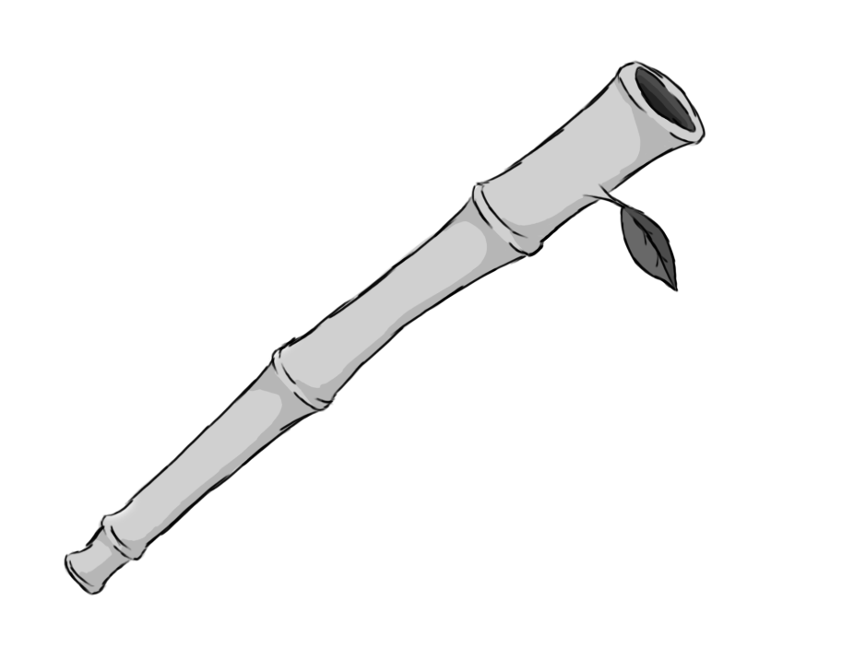

Figure - Weapon: Staff

**Brief Synopsis**

The staff is a low damage but high-speed combo weapon. Its attacks are able to follow up into several more attacks by pressing the attack button repeatedly. The staff is also able to return any projectile attacks fired at the player.

**Special Ability**

**Hover:**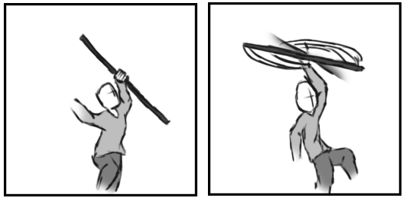

Figure 2 - Animation Storyboard: Hover

**Special:** When aerial, the player swings there staff above, creating a helicopter blade effect. This slows the decent of the player, allowing them to reach further areas the double jump might fail to grant them access too.

**Combat Ability’s**

**Continuous strikes:   
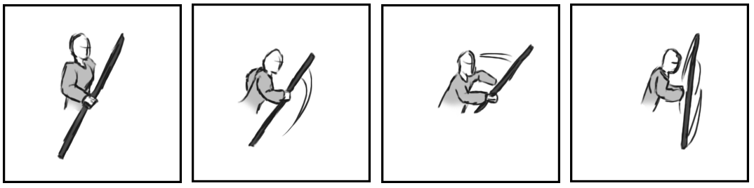**

Figure - Animation Storyboard: Continuous Strikes

**While grounded and stationary**: The player swings the staff quickly attacks anything in front of them. Each strike has the ability to knock back any projectile thrown at the player.

**Running Strike:  
**

Figure - Animation Storyboard: Running Strike

**While grounded and in motion:** Similar to the continuous strikes except movement is maintained while swinging.

**Downward strike:**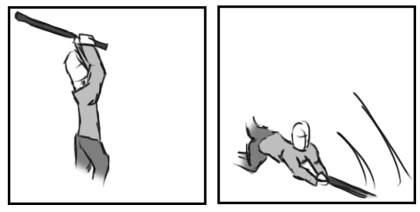

Figure 5 - Animation Storyboard: Downward Strike

**While aerial:** The player slams the staff down to the ground, attacking enemies directly in front of them.